**INFORMATICS AND COMPUTATIONAL SCIENCE**

**UNIVERSITY COLLEGE OF SCIENCE**,

**MOHANLAL SHUKHADIA UNIVERSITY, UDAIPUR**

**BACHELOR OF COMPUTER APPLICATION**

**( A Choice Based Credit System )**



**BCA-6th SEMESTER**

**2023 – 24**

**[BATCH-A]**

**PROGRESS REPORT ON**

ON

**“CareerVista”**

**Submitted To :- Submitted By :-**

**Mr. Jitesh Kumar Mr. Anand Dubey**

### 1. Name of the Student: - Anand Dubey

### 2. Name and Address of the Organization:

### _____________________________________________________________________________________________________________________________________________________________________________________________________________________________________________________________________________________________________________________________________

### 3. Division/Department in Which Working:

_______________________________________________________________________________________

### 4. Name and Designation of the Supervisor:

### ___________________________________________________________________________________________________________________________________________________________________________________________________

### 5. Title of the Project:- “CareerVista”

### 6. Platform on Which Working:

MERN Stack (MongoDB, Express.js, React.js, Node.js)

### 7. Software Tools Being Used:

* MongoDB
* Visual Studio Code
* Postman (for API testing)
* Git (for version control)

### 8. Period of Progress:- [1st June to 15th June, 2024]

### 9. Description of Progress Made with Screenshots:

#### Week 1 (1st June - 7th June):

#### Backend Development:

* **API for Recruiter:**
  + **Description:** Developed APIs to handle recruiter functionalities including registration, login, profile management, and job postings.
  + **Endpoints:**
    - POST /api/recruiter/register: Registers a new recruiter.
    - POST /api/recruiter/login: Authenticates a recruiter.
* **API for Employee:**
  + **Description:** Created APIs for employee functionalities including registration, login, profile management, job search, and application submission.
  + **Endpoints:**
    - POST /api/employee/register: Registers a new employee.
    - POST /api/employee/login: Authenticates an employee.
* **API for Jobs:**
  + **Description:** Developed APIs for managing job listings, including CRUD operations.
  + **Endpoints:**
    - POST /api/jobs: Creates a new job listing.
    - GET /api/jobs: Retrieves all job listings.
    - GET /api/jobs/:id: Retrieves a job listing by ID.
    - PUT /api/jobs/:id: Updates a job listing by ID.
    - DELETE /api/jobs/:id: Deletes a job listing by ID.
  + **Screenshot:**

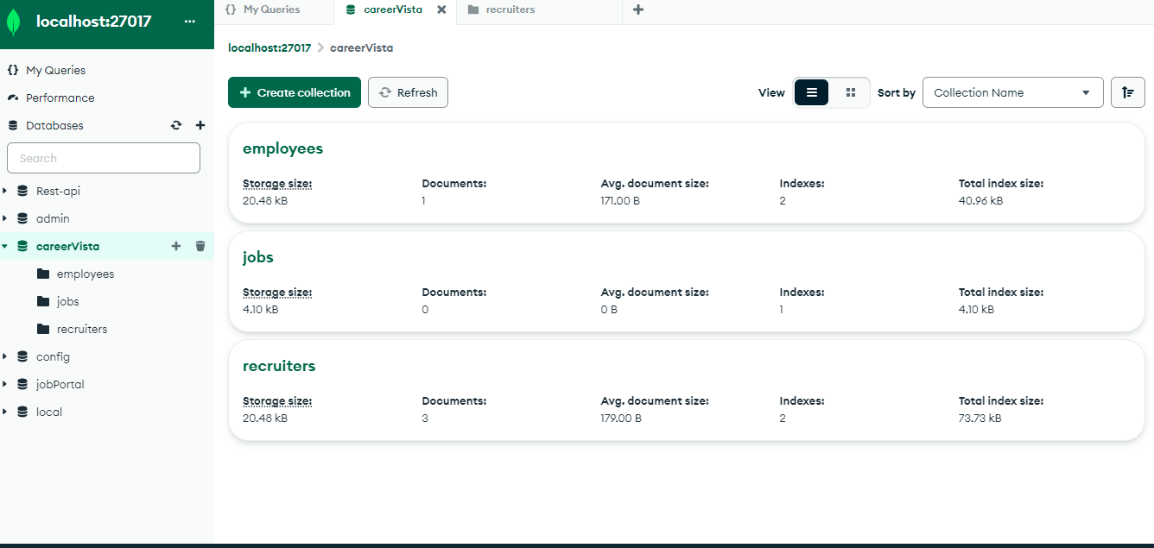

#### Week 2 (8th June - 15th June):

#### Frontend Development:

* **Home, About, and Contact Pages:**
  + **Description:** Created responsive Home, About, and Contact pages using React.js with navigation integrated.
  + **Screenshots:**
    - Home Page:

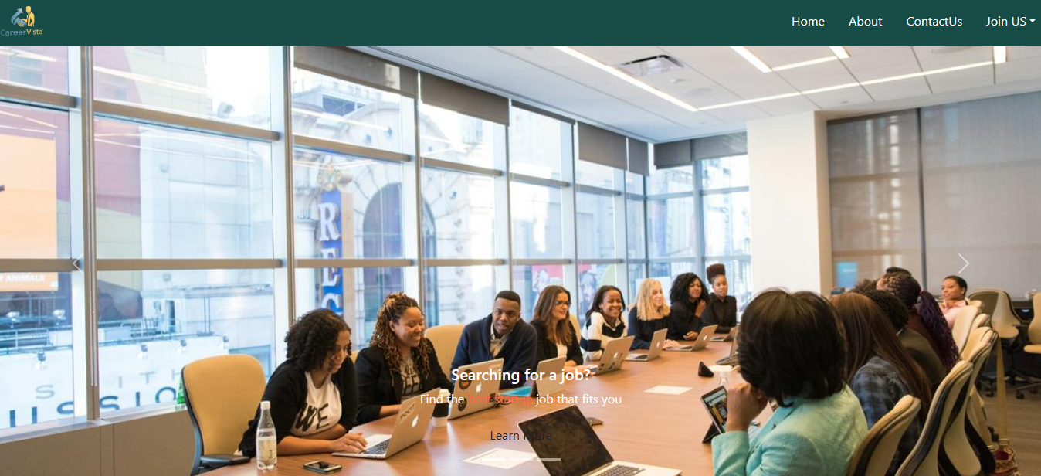

* + - About Page:

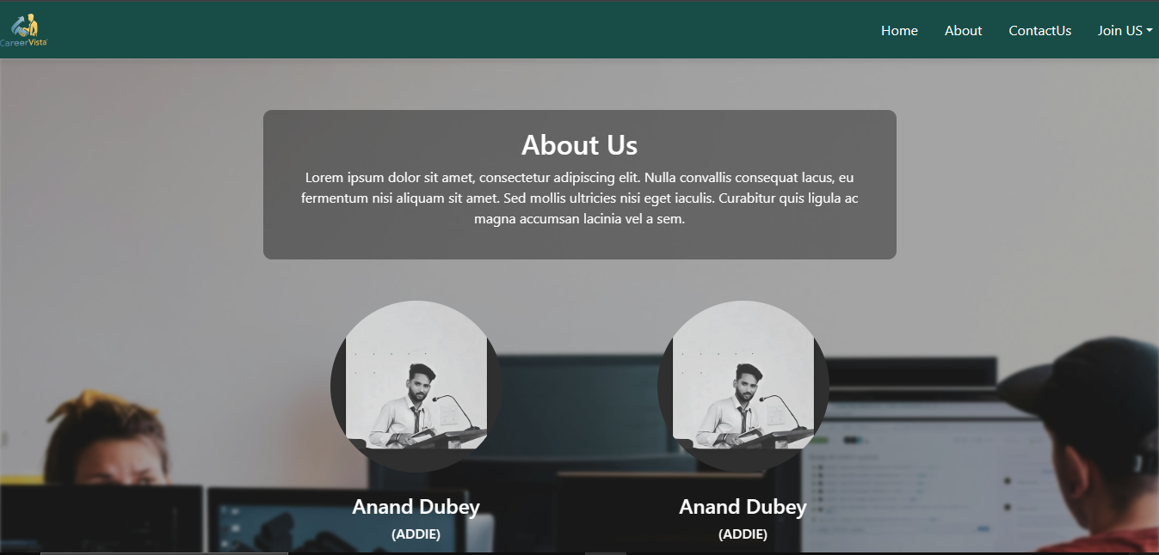

* + - Contact Page:

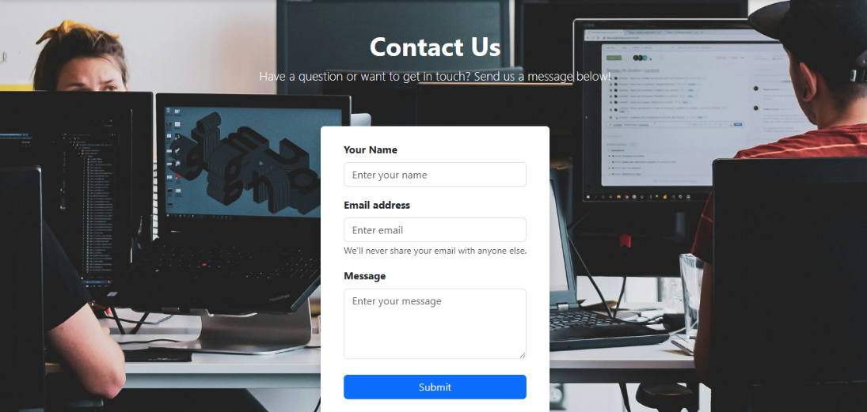

* **Registration Form with Dynamic Fields:**
  + **Description:** Developed a registration form with dynamic fields for employees and recruiters. Implemented form validation and error handling.
  + **Screenshot:**

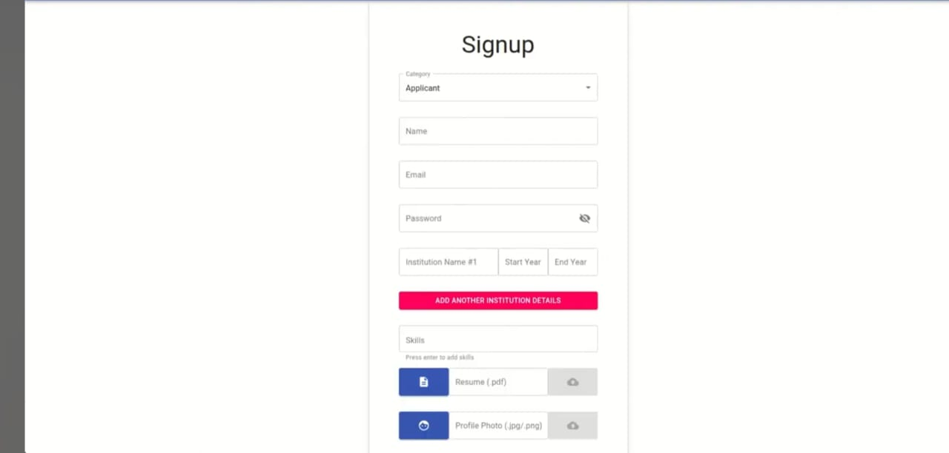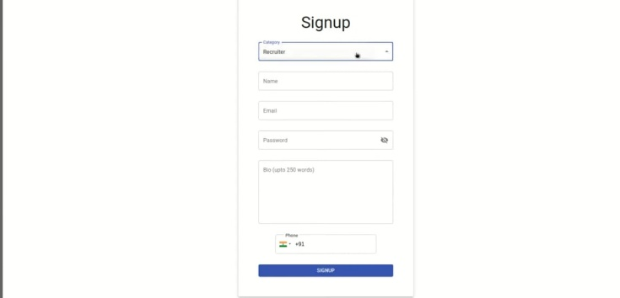

* **Separate Login Pages for Employee and Recruiter:**
  + **Description:** Created separate login pages for employees and recruiters, each with its own authentication flow.
  + **Screenshots:**
    - Employee Login Page:

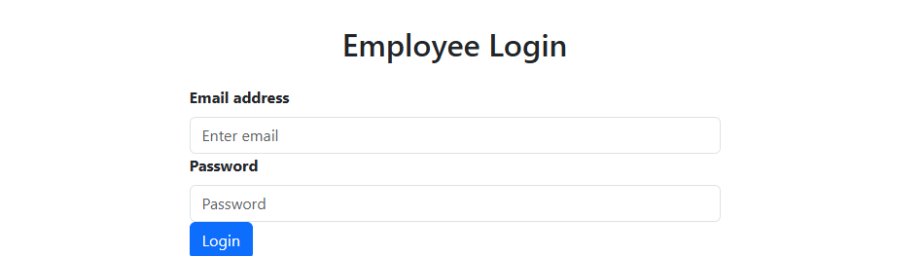

* + - Recruiter Login Page:

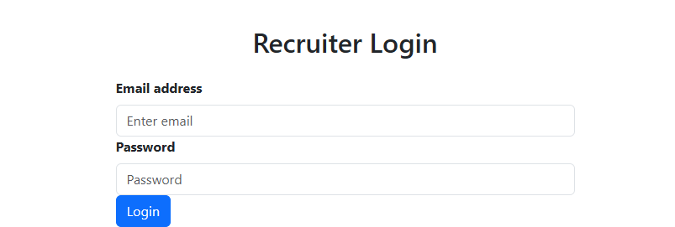

* **Employee Homepage and Job Categories:**
  + **Description:** Developed the employee homepage displaying job categories and featured jobs. Integrated with the jobs API for dynamic content.
  + **Screenshot:**

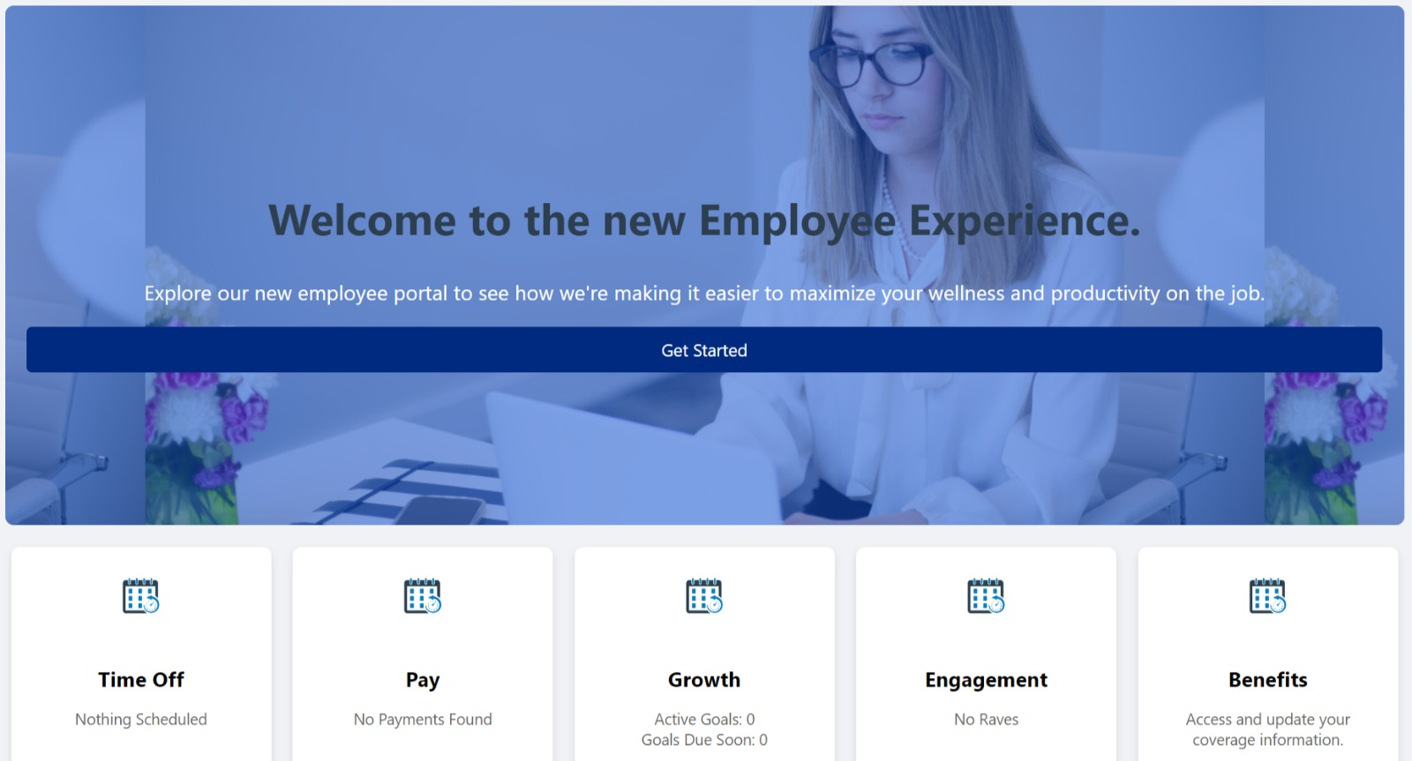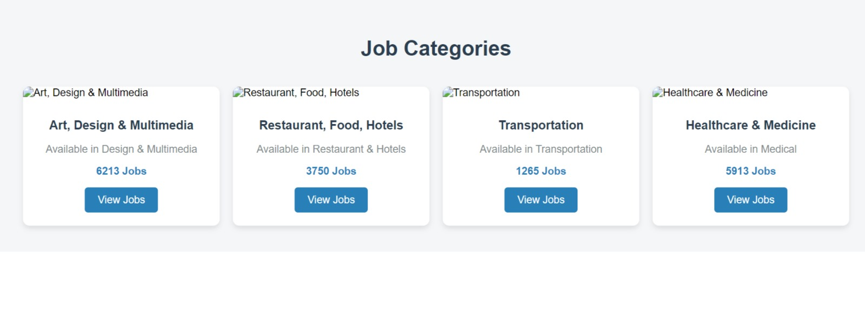

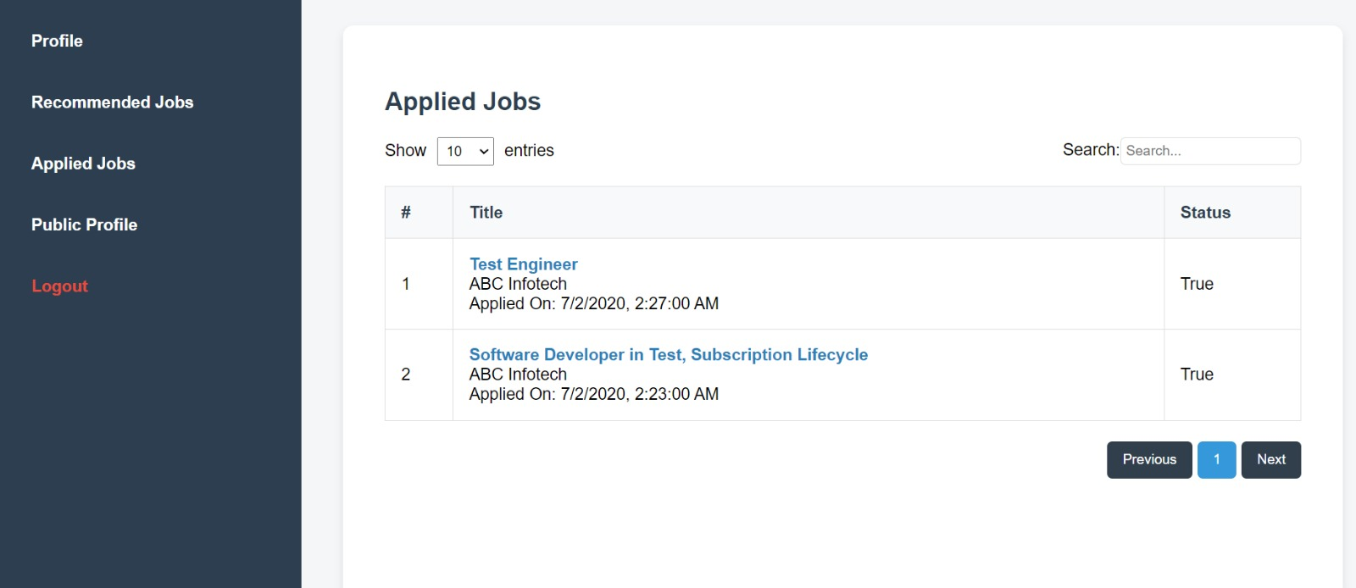

* **Components for Admin Panel:**
  + **Description:** Created initial components for the admin panel, including user management and job listing management.
  + **Screenshot:**

